**NALAIYA THIRAN**

**WEEK 1 REPORT**

**Mentor Name:** Ms. Banupriya N

**Team ID:** PNT2022TMID15707

**Github ID:** https://github.com/IBM-EPBL/IBM-Project-25576-1664170785

**Team Leader Name:** Joseph Rio Jacob T J

**Team Members Name:**

1. Kamal A
2. Karthikeyan R
3. Dilip R

**Domain:** Internet of Things (IoT)

**Project:** IoT Based Safety Gadget for Child Safety Monitoring & Notification

**Phase 1 Description:** Preparation Phase (Prerequisites, Registrations, Environment Set-up, etc.)

* 1. Accessed the resources (courses) in project dashboard

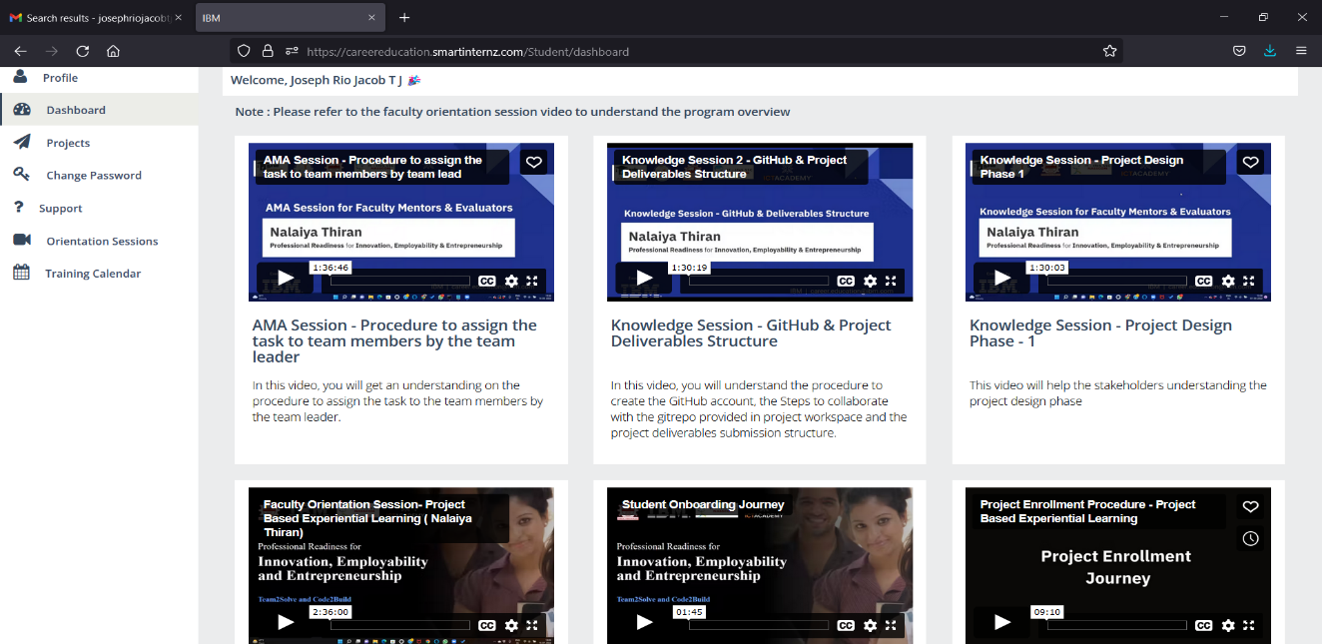

1.2 Joined the mentoring channel via platform & rocket-chat mobile app

1.3 Accessed the guided project workspace

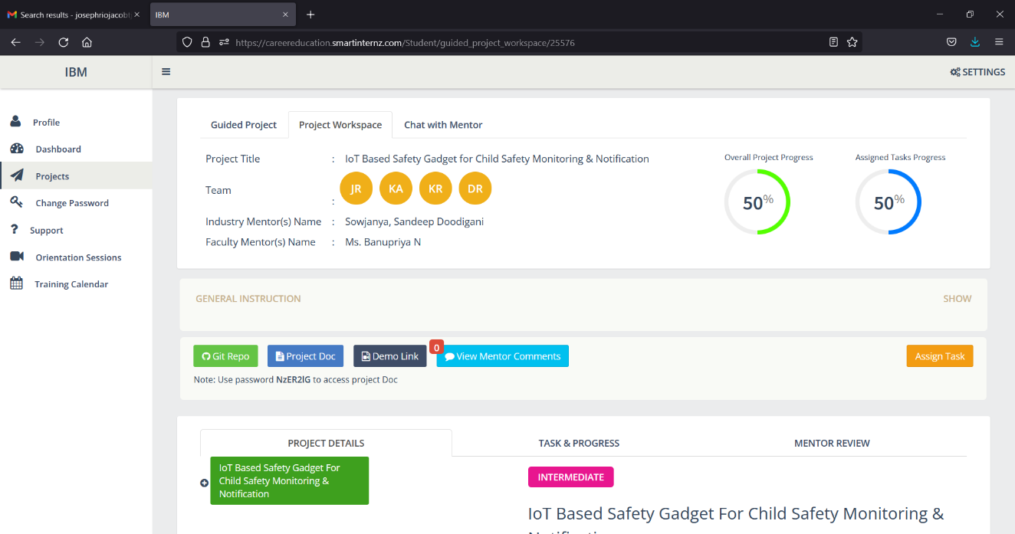

1.4 Registered on IBM Academic Initiative & Apply Feature code for IBM Cloud Credits

1.5 Created GitHub account & collaborate with Project Repository in project workspace

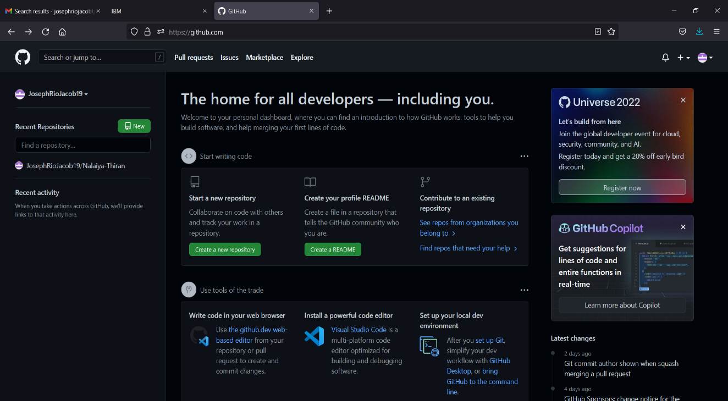

1.6 Set-up the Laptop / Computers based on the prerequisites for each technology track

**Tinker-cad Account**

